Session 1
Ques1)
Explain the step-by-step process of compiling and running a Java program, including the roles of JVM, JRE, and JDK?
1. Step-by-Step Process of Compiling and Running a Java Program
Java follows the process:
Java Source Code (.java) → Compiler → Bytecode (.class) → JVM → Machine Code → Output
Step 1: Write the Java Program
Create a file with the .java extension.
Example: Hello.java
Step 2: Compile the Program
Open CMD/Terminal and run:
javac Hello.java
Step 3: Run the Program
Run:
java Hello
The JVM loads and executes the bytecode.
Role of JDK, JRE and JVM
Component | Role
JDK | Used by developers to develop, compile and run Java programs
JRE | Provides the environment required to run Java applications
JVM | Executes Java bytecode and converts it into machine-level instructions

Ques2) Write a program using conditional statements to check whether a number is even, odd, and divisible by 3.
import java.util.Scanner;

class NumberCheck {
public static void main(String[] args) {

Scanner sc = new Scanner(System.in);

System.out.print("Enter a number: ");
int num = sc.nextInt();

if (num % 2 == 0) {
System.out.println("The number is Even.");
} else {
System.out.println("The number is Odd.");
}

if (num % 3 == 0) {
System.out.println("The number is divisible by 3.");
} else {
System.out.println("The number is not divisible by 3.");
}

sc.close();
}
}
Output
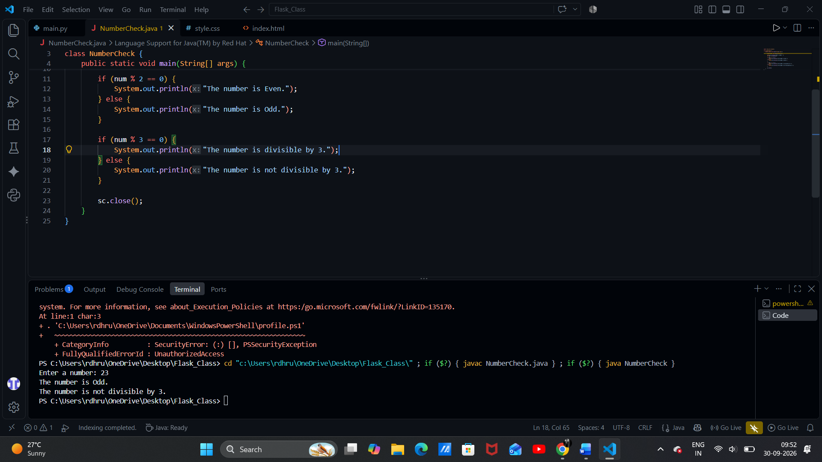

Ques3) Develop a calculator application using object-oriented programming concepts in Java.
import java.util.Scanner;

class Calculator {

// Data members
private double num1;
private double num2;

// Constructor
Calculator(double num1, double num2) {
this.num1 = num1;
this.num2 = num2;
}

// Addition method
double add() {
return num1 + num2;
}

// Subtraction method
double subtract() {
return num1 - num2;
}

// Multiplication method
double multiply() {
return num1 * num2;
}

// Division method
double divide() {
if (num2 == 0) {
System.out.println("Cannot divide by zero.");
return 0;
}
return num1 / num2;
}
}

public class Main {
public static void main(String[] args) {

Scanner sc = new Scanner(System.in);

System.out.print("Enter first number: ");
double num1 = sc.nextDouble();

System.out.print("Enter second number: ");
double num2 = sc.nextDouble();

System.out.println("\n1. Addition");
System.out.println("2. Subtraction");
System.out.println("3. Multiplication");
System.out.println("4. Division");

System.out.print("Enter your choice: ");
int choice = sc.nextInt();

// Creating object
Calculator calc = new Calculator(num1, num2);

switch (choice) {

case 1:
System.out.println("Result = " + calc.add());
break;

case 2:
System.out.println("Result = " + calc.subtract());
break;

case 3:
System.out.println("Result = " + calc.multiply());
break;

case 4:
System.out.println("Result = " + calc.divide());
break;

default:
System.out.println("Invalid choice!");
}

sc.close();
}
}
Output
